**Modeling Clinical Heterogeneity in Lupus Nephritis With a Stochastic Flare System**

Chiara Corbo-Galli, Hannah Ma, Silpol Dhiantravan, Sean Pascoe

Code/Data Availability Statement: All code needed to reproduce the figures is available online at <https://github.com/pascoesean/lupus-model>. Raw Data from the ACCESS study can be retrieved from the [Immune Tolerance Network’s Trial Share platform](https://www.itntrialshare.org/project/Studies/ITN034AIPUBLIC/Study%20Data/begin.view).

### I. Introduction

Systemic Lupus Erythematosus (SLE) is a heterogeneous autoimmune disease characterized by the accumulation of autoantibodies, and has a vast array of clinical manifestations, thus making it difficult to find relevant treatments [1]. This experiment sets out to create a mathematical model of kidney damage flare ups in ongoing Lupus Nephritis (LN), the condition of kidney damage caused by SLE. Modeling attempts for disease dynamics during SLE in the literature are sparse [2], and often either too complex to be practical to implement or too broad to capture complex immune system dynamics [1,2,3]. To address this, we have reimplemented a relatively simple model introduced by Budu-Grajdeanu et al [1], while adding a stochastic mini-flare element to our dynamical system to model the intricate fluctuations of immune dynamics in SLE without losing generalizability to patient data. In this report, we demonstrate that the general dynamics of the system are reiterated in our model with stochastic flare, then fit these models to new patient data from the ACCESS clinical trial to reveal population level variation in model parameters, using our stochastically driven model to understand patient-to-patient heterogeneity in SLE.

The original model, proposed by Budu-Grajdeanu et al, models LN disease progression as the interactions between Immune Complexes formed by autoantibodies, pro-inflammatory, and anti-inflammatory immune processes drive tissue damage. The changes between these four compartments are then modeled, and parameters are chosen as biologically relevant values or determined by fitting the system of ODEs to patient data (done separately for 4 different patients), where renal biomarkers were used to approximate values of state variables. Notably, three parameters, si , sid, and sa (Table 1), were fit piecewise to patient data, meaning they were allowed to vary to fit each time point in the original published data. The ability of these ODEs to recapitulate patient data trends is noted, and then parameter values are modified to indicate what could happen in different perturbational environments for each patient, yielding an *in silico* method for personalized treatment design.

### II. Methods

***Implementation of the model as described by Budu-Grajdeanu et al:***

***Chart 1:*** Schematic representation of model system

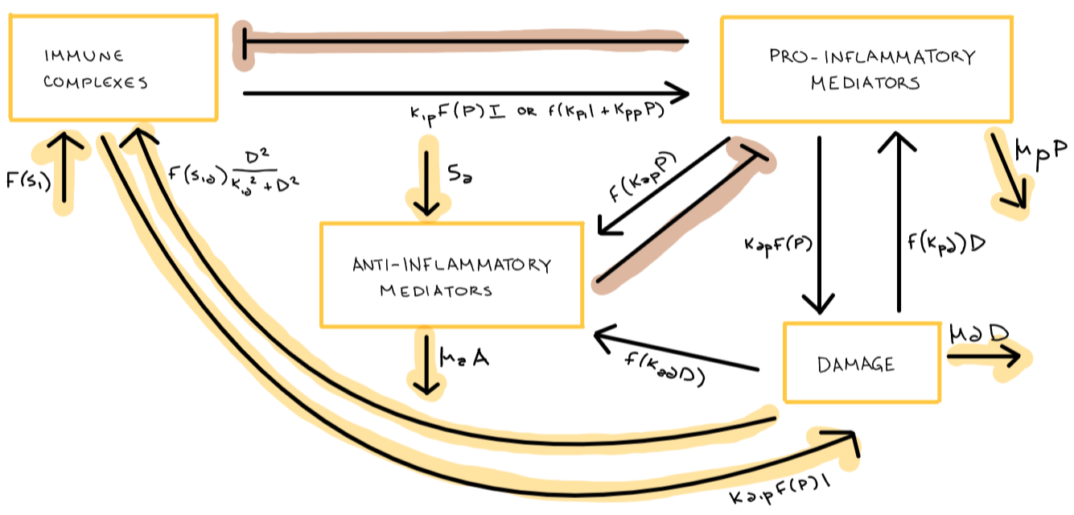  
***Chart 1:*** Proposed model of the system. Arrows highlighted in yellow were added to the model based on the system of ODEs provided. Arrows highlighted in brown are inhibition arrows that were part of the given model schematic but did not have a specified parameter in the system of ODEs.

The equations and parameters for the model are taken from the ones provided by Budu-Grajdeanu et al. Default parameter values are taken from Table 1, based on those of patient 416.

$$(1) \frac{dI}{dt}=f\left(s_{i}\right)+f\left(s_{id}\right)\frac{D^{2}}{k_{id}^{2}+D^{2}}-k_{ip}f\left(P\right)I$$

$$(2) \frac{dD}{dt}= k_{dip}f\left(P\right)I+k_{dp}f\left(P\right)-μ_{d}D$$

$$(3) \frac{dP}{dt}=f\left(k_{pi}I+k_{pp}P\right)I+f\left(k_{pd}D\right)-μ_{p}P$$

(4) $\frac{dA}{dt}=s_{a}+f\left(k_{ap}P+k_{ad}D\right)-μ_{a}A$

Equations 1-4. The four equations for the system of ODEs, constituting Immune Complexes (I), Damage (D), Proinflammatory Mediators (P), and Anti-Inflammatory Mediators from top to bottom (A).

(5) $f\left(x\right) = \frac{x}{1 + (A/A_{inf})^{2}}$

Equation 5. *si* and *sid* are additionally controlled/inhibited by both exogenous (treatment) and endogenous anti-inflammatory mediators. All functions *f* in Equations 1-4 thus follow the format of Equation 5, to model the negative inhibition by the anti inflammatory mediators on other compartments as a “dimming effect”, where the strength of this dimming depends on the current level of A as well as the parameter Ainf.

Our model parameters are defined as follows:

***Table 1:*** Model Parameters

|  |  |  |
| --- | --- | --- |
| Parameter | Definition | Unit |
| *si = 0.002 | rate that immune complexes deposit in the kidneys | I-units day-1 |
| *sid = 0.015 | immune response to accumulation of damaged cells | I-units day-1 |
| kid **=** 1 | Rate of immune complex formation due to damage | D-units |
| kip **=** 0.025 | rate of immune complex removal from system | P-units-1 day-1 |
| Kpi = 0.13 | rate of mediator activation and recruitment | P-units I-units-1 day-1 |
| kpp **=** 0.02 | immune response amplified by existing inflammatory response (kpi) | Day-1 |
| kpd **=** 0.001 | rate of activation for pro-inflammatory agents as a result of cytokine release or induced by damaged tissue | P units D units-1 day-1 |
| μp **=** 0.06 | decay of pro-inflammatory mediators | Day-1 |
| kdip **=** 0.025 | rate of phagocytosis of immune complexes by immune cells | P units-1 day-1 |
| kdp **=** 0.27 | rate at which collateral damage is produced by pro-inflammatory mediators | D-units P-units-1 day-1 |
| μd **=** 0.04 | decay rate of damage (repair, resolution, and regeneration of tissue) | Day-1 |
| *sa **=** 0.05 | addition of anti-inflammatory drugs | A-units day-1 |
| kap **=** 0.022 | intrarenal production of anti-inflammatory mediators | A-units P-units-1 day-1 |
| kad **=** 0.22 | intrarenal rate of tissue damage | A-units D-units-1 day-1 |
| μa **=** 2.2 | rate of anti-inflammatory agent degradation | Day-1 |
| Ainf **=** 0.45 | Endogenous anti-inflammatory agents | A-units |

***Table 1:*** List of parameter names, default values, meaning, and units. Parameters typically vary from 0 to 1. Since the model greatly simplifies the cellular processes at play and often represent entire classes of molecules in bulk, parameters are given in arbitrary units labeled I- P- D- or A-units. * indicates that this parameter was fit to data piecewise in Budu-Grajdeanu et al.

This system of ODEs was then solved using time dependent functions and scipy’s *odeint*.

***Implementing a stochastic fluctuation element:***

Because this model reaches a fixed point, it cannot fit to dynamics that are not fixed unless parameters are modulated piecewise, as done in the original paper. To recapitulate these complex dynamics without fitting to each individual time point, we modified our ODE system such that, at each timepoint, a “mini-flare” is initiated with probability 0.02, wherein the values for Si and Sid are multiplied by 5 while the value for Sa is divided by 4; thus adding small perturbations back into the timeseries.

***Fitting to New Patient Data:***

In order to assess the performance of our model on new data, we downloaded timeseries data from the ACCESS trial [4], which we then filtered to include 46 patients with more than 14 non-missing data points for urinary protein to creatinine ratio, the metric of damaged that was fit to in Budu-Grajdeanu et al. We then trained original models with no perturbation based on average values from the four patient’s parameters from the original paper, while allowing four parameters, Kpi, Kdip, Kap, and Kip to vary to fit the data. Best fit values for these parameters were found for each patient using Levenberg-Marquardt least squares as implemented in the python module lmfit.

### III. Results

#### 

#### Initial Implementation + Fixed Points

After implementing the model with patient 416’s values, it was possible to recreate Figure 5A from the study. Interestingly, the dynamics of the model still show an initial flare peak with a stochastic style model, but at a different time. Most importantly, the Lupus stochastic model is able to obtain various flare cycles without fitting to data explicitly, which is more relevant for patient dynamics.

|  |  |
| --- | --- |
|  |  |

***Figure 1: Original model recapitulated and compared with stochastic element***

|  |  |  |
| --- | --- | --- |
|  | B. | C. |

***Figure 1:*** (A) Initial model for patient 416 from Budu-Grajdeanu et al. 2010 (B) Recapitulation of that model using SciPy (C) SciPy model with stochastic changes implemented

Once we had established that we were able to recreate both the specific dynamics (Fig 1B) and the more general dynamics (Fig 1C), we set out to find fixed points of the system, to understand the end behavior of our model. Here, it is worth noting that, although our model contains negative feedback, this negative feedback is encoded as a dimmer effect in our A/Ainf function, rather than a direct decrease caused by the anti-inflammatory compartment on other compartments, which yields non-oscillatory dynamics. For this reason, we can computationally solve for fixed points, and approximate limiting values for our models with stochastic perturbation introduced:

**Piecewise/Original Model fixed points:**

There are fixed points for the following time ranges at:

|  |  |  |  |  |
| --- | --- | --- | --- | --- |
| Time range (days) | I | P | D | A |
| 0 ≤ t ≤ 60 | 0.405 | 0.617 | 2.377 | 0.157 |
| 60 < t ≤ 120 | 0.288 | 0.455 | 1.783 | 0.149 |
| 120 < t ≤ 180 | 0.762 | 0.989 | 0.347 | 0.196 |
| 180 < t ≤ 240 | 0.254 | 0.333 | 1.127 | 0.193 |
| t > 240 | 0.704 | 0.902 | 3.115 | 0.199 |

**Stochastic Model fixed points:**

Looking at the time series of the stochastic model (Fig 1c), it appears as though there is an unstable fixed point around at t=120 with I=1, P=1.4, D=5.2, A=0.3. Additionally, the graph appears to settle towards the end suggesting a fixed point around I=0.7, P=1.1, D=4.2, A=0.2. However, given that we are changing the parameters at random timepoints to model this as a stochastic process, the system will never reach these points.

Additionally, we were able to algebraically solve for nullclines using the simplification f(x) = x.

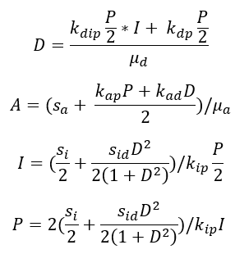

Although it is hard to understand the nullclines themselves without other simplifying assumptions, they do show that in general, the fixed points can be thought of as obtained for certain ratios of the state variables based on the given parameters.

#### 

#### Modulating Parameter Values

Once we had investigated the fixed points of our model, we modulated specific parameters to investigate how different physiological conditions would affect the renal damage incurred in LN:

***Figure 2***: Changing Si

|  |  |
| --- | --- |
| *A.* | *B.* |
|
|
|
| *C.* | *D.* |

***Figure 2.***(A)Graphs of the original model with various proportions of Si and (B) the implemented stochastic model for Si values 0.0001, 0.001, 0.004, and 0.01. (C) Original model with constant Si = 0.01 (D) Original model with constant Si = 0.1

To preserve the piecewise nature of the original model, we chose to modulate Si as a proportion of the original value during each pre-defined time period, while keeping Sid and Sa unchanged (so each Si value was multiplied by 0.01, 0.5, 1.5, etc.). Interestingly, these perturbations did not seem to affect the flare in either case. Instead, changing Si primarily changes D during t between 0 and 140 with almost-imperceptible changes to other variables in the same time range. Larger Si create steeper slopes during the 2-4 months before flare (60 < t < 120), while smaller Si create steeper slopes during 0 < t < 60. If Si is held constant throughout the trajectory and raised 10 or 100x, then we begin to see some changes in the other variables and in the changes to D near the flare’s peak. However, the effect of manipulating Si still appears to primarily affect the t between 0-120 period, with larger Si corresponding to steeper slopes in the variables’ growth. Based on the shape of this curve, this may be caused by the 2nd order Hill kinetics term at play in the dI equation. In the stochastic system, larger Si once again increase the slope of the first two months in the simulation, but also the slope of all increasing regions in the trajectory of tissue damage over the entire simulation. The flare trajectory for Si = 0.0001 is the only one that depresses as time increases, concurring with the idea that maintaining low Si is important for Lupus maintenance.

***Figure 3:*** Changing Sa

|  |  |
| --- | --- |
| A. |  |
| B. |  |
| C. |  |
| D. |  |

***Figure 3:***Graphs of the original model (left) and the implemented stochastic model (right) for Sa values 0.001 (A), 0.07(B), 0.5(C), and 1.0(D). Default Sa value for the original model and the stochastic model were 0.05 and 0.2 respectively.

Next, we modulated Sa, which represents additional anti-inflammatory agents introduced to the system, as through therapy. For the original model, it is clear that as Sa goes up the amount of damage goes down, especially after Sa = ~0.3. This makes sense as we would expect damage to decrease with therapy. We also see that larger values of Sa during a pulse cause a blip in the anti-inflammatory compartment, which then returns to baseline levels, and which is much larger in the original model. Also interesting is that in the stochastic model when Sa is 1 the graphs of P and I seem to practically overlap after a time, and are very strongly correlated with the graph for damage. This is not true when Sa is very small, and you can see the I is a lot more spikey and variable than D.

#### 

***Figure 4:*** Changing Ainf

|  |  |
| --- | --- |
|  |  |
|  |  |
|  |  |
|  |  |
|  |  |

***Figure 4:*** Graphs for a changing Ainf value, with those for the original model given on the left and those for the stochastic model given on the right. Ainf increases from top to bottom.

Ainf represents the endogenous anti-inflammatory mediators, which is a segment of A, representing all anti-inflammatory mediators endogenous and exogenous. However, the integration of this into the original paper appears insufficient, as the authors provide a hardcoded value for Ainf that is not backed by any reference or calculation. The paper states that anti-inflammatory therapy would clear pro-inflammatory mediators, lowering inflammation but interfering in the ability to clear damage. Surprisingly when recreating this trend in the original model, we see the opposite effect. A low Ainf causes an increase in inflammation and decrease in damage. In the stochastic model, we removed the term for therapy, meaning that anti-inflammation becomes largely dependent on the intrarenal deposits of anti-inflammatory mediators due to inflammation and damage. With low Ainf, the stochastic model breaks into low-level oscillations of damage, pro-inflammatory mediators, and anti-inflammatory mediators with inflammation steadily increasing. As we increase Ainf, initially all values increase with damage increasing most greatly. With continual increase, damage increases and the rest of the variables decrease. One interesting change in the behavior of both models with the increase of A_inf is that the shape of the model’s behavior becomes smoother, leveling out and returning slowly rather than with spikier flares.

***Figure 5:*** Changing μd

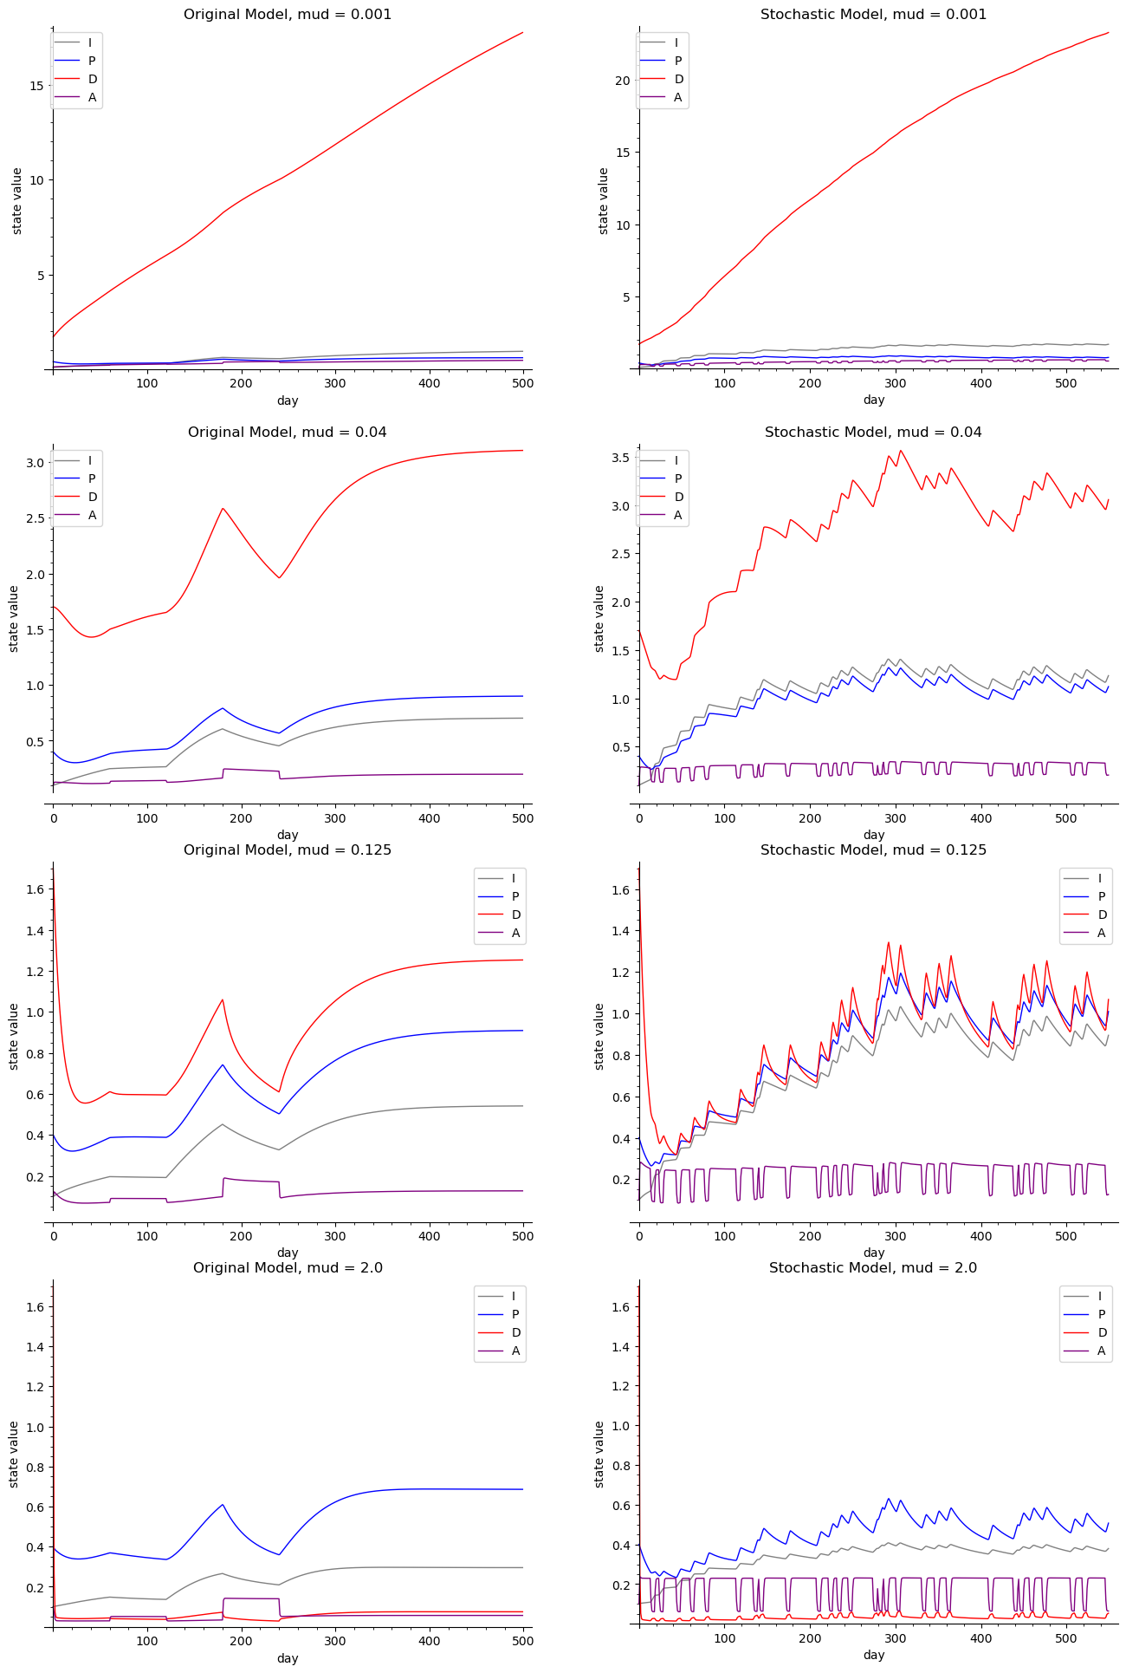

***Figure 5:*** Simulations from the original model (left) and stochastic model (right). Values of μd were the only changed values from standard values for patient 416.

While fitting to other parameters in the data, outside of those that were involved in the scaling of negative inhibition of anti-inflammatory processes (Ainf) and those that were involved in the piecewise function, the model goes to a fixed point (Fig 5, Fig S2). Specifically, changing each of these parameters individually shifts the fixed point ratios of our state variables, thus shifting an individual from high levels of damage to low, as suggested by the relationships between state variables in our nullclines. For the values for μd  , we see this as very small values, corresponding to a low rate of damage resolution, cause damage to clearly outweigh other state variables, whereas very large values

#### 

#### Fitting to new Data

Once we had established that we could recapitulate the relevant dynamics from the original model with our stochastic model, we attempted to fit both models to new data from the ACCESS Trial study [4]. To speed up computations, only the parameters Kap, Kdip, Kip, and Kpi were modulated. These parameters were chosen for biological importance and because they tended to vary between the four patients in the previous study [1]. These parameters were then sequentially tuned to each dataset, either with fixed values of si, sid, and sa or with values of si, sid, and sa that were randomly modulated as discussed in methods.

***Figure 6:*** Fitting Models to New Data

|  |  |
| --- | --- |
| *A.* | *B.* |
| *C.* | *D.* |
| E. | |

***Figure 6:*** Fitted values for D vs. Urinary Protein to Creatinine ratio as measured in [4], for two representative patients; using the original model (a,c) or the stochastic model (b,d). All others can be found in our github repository in [view_saved.ipynb](https://github.com/pascoesean/lupus-model/blob/main/view_saved.ipynb). (e) Fitted values from the fixed model (top four panels) and the stochastic model (bottom four panels) for four different parameters: kap, kdip, kip, and kpi. Each dot represents the fitted value for that parameter from a 500 day timeseries of kidney damage data.

Here, our stochastic model was able to achieve similar residual error, but was noticeably more dynamic than the model with fixed si, sid, and sa; which represents the improvement of the stochastic model at adapting to new data rather than fitting specifically to a single individual (Fig 6a). Additionally, after running these simulations with 46 different patients from the ACCESS study [4], we observed that values of Kpi were generally higher for white SLE patients than for black SLE patients (fig 6b). This difference was more pronounced in the stochastic model than in the fixed model, which again makes sense because the stochastic model was less likely to fit to one trend and thus more reliably captured heterogeneity throughout the patient population. These four parameters did not differ significantly based on the age of the patient (Fig S2).

### IV. Discussion

Overall, adding a stochastic element to the piecewise-parameterized model proposed by Budu-Grajdeanu et al. has allowed us to investigate the dynamics of renal flare in Lupus Nephritis in perturbed state that models immune variability, while also providing greater extrapolation potential. Notably, we were able to completely capture the dynamics of one patient in the original model via piecewise time dependence of three parameters, and we were then able to recreate the general end time trends of the model with our included stochastic fluctuations.

Manipulating our chosen parameters (Sa, Si, Ainf, and μd ) on the models mostly produced results that concurred with our expectations. Increased values of Si result in more rapidly accumulating tissue damage as well as higher expected and peak amounts of damage during flares, and decreasing it in the stochastic model would depress levels of tissue damage over time. The opposite is true when Sa values were changed, although overall A levels appear mostly unchanged even when Sa values are increased. Similarly, when μd is increased in both the original and stochastic models, levels of damage drop dramatically, and levels of pro-inflammatory mediators also observe a decrease. We did observe some unusual behavior in the system at extremely high values of Sa in the form of box-wave increases in A, although we are uncertain whether these are reflective of biological behavior or artifacts of the model setup. In addition, while low Ainf was suggested by the authors to suppress inflammation, the opposite was observed when explored on both the original and stochastic model.

Because our stochastic model is able to capture the same general trends as the original model while also better adapting to new data, we conclude that the stochastic term model serves as a powerful addition to autoimmune modeling. Additionally, our stochastic model was able to pick out salient general differences between Black and White SLE patients in the parameter Kpi, indicating that pro-inflammatory mediators may be more readily recruited in individuals of European descent. Taken in tandem with previous research that has indicated that lupus nephritis symptoms are less severe in White patients [5], this suggests that attraction of pro-inflammatory mediators to the kidneys may be an underlying biological factor that contributes to lessened disease severity in LN. Further investigation could involve in vitro experiments with organoids that evaluate the rate that pro-inflammatory mediators are introduced to further evaluate this effect. These trends were not as evident with the standard model, which only yields stable fixed point limit behavior and thus cannot as accurately represent the dynamics of change throughout time. Thus, our implementation of a stochastic element to this simple model of damage in LN effectively investigated the impact of different physiological changes, while also being adaptable enough to yield biological insight about patient heterogeneity in SLE.

### V. REFERENCES

### 

[1] Budu-Grajdeanu, P., Schugart, R. C., Friedman, A., Birmingham, D. J., & Rovin, B. H. (2010). Mathematical framework for human SLE Nephritis: disease dynamics and urine biomarkers. Theoretical biology & medical modelling, 7, 14. <https://doi.org/10.1186/1742-4682-7-14>

[2] Ugolkov, Y., Nikitich, A., Leon, C., Helmlinger, G., Peskov, K., Sokolov, V., & Volkova, A. (2024). Mathematical modeling in autoimmune diseases: from theory to clinical application. Frontiers in immunology, 15, 1371620. <https://doi.org/10.3389/fimmu.2024.1371620>

[3] Yazdani, A., Bahrami, F., Pourgholaminejad, A., & Moghadasali, R. (2023). A biological and a mathematical model of SLE treated by mesenchymal stem cells covering all the stages of the disease. Theory in biosciences = Theorie in den Biowissenschaften, 142(2), 167–179. https://doi.org/10.1007/s12064-023-00390-4

### [4] ACCESS Trial Group (2014). Treatment of lupus nephritis with abatacept: the Abatacept and Cyclophosphamide Combination Efficacy and Safety Study. Arthritis & rheumatology (Hoboken, N.J.), 66(11), 3096–3104. <https://doi.org/10.1002/art.38790>

[5] Maningding, E., Dall'Era, M., Trupin, L., Murphy, L. B., & Yazdany, J. (2020). Racial and Ethnic Differences in the Prevalence and Time to Onset of Manifestations of Systemic Lupus Erythematosus: The California Lupus Surveillance Project. Arthritis care & research, 72(5), 622–629. https://doi.org/10.1002/acr.23887

### SUPPLEMENTS:

***Figure S1:*** Modulating Kpi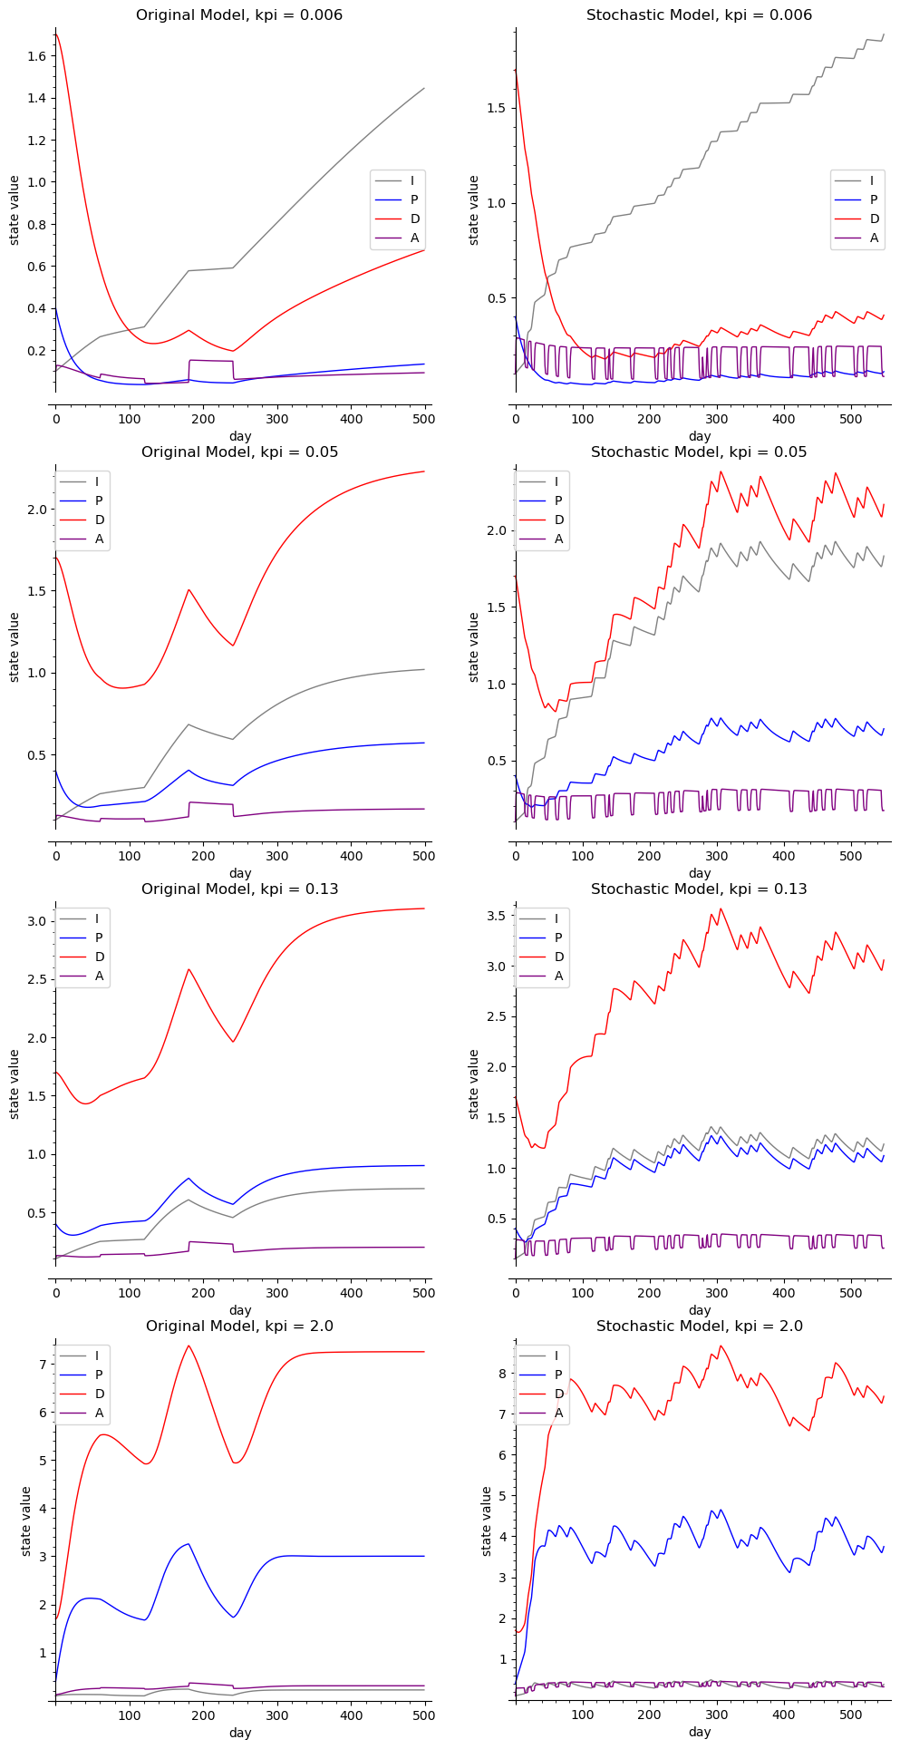

***Figure 5:*** Simulations from the original model (left) and stochastic model (right). Values of kpi were the only changed parameters from standard values for patient 416.

***Figure S2:*** Fitted Parameter Values by Age

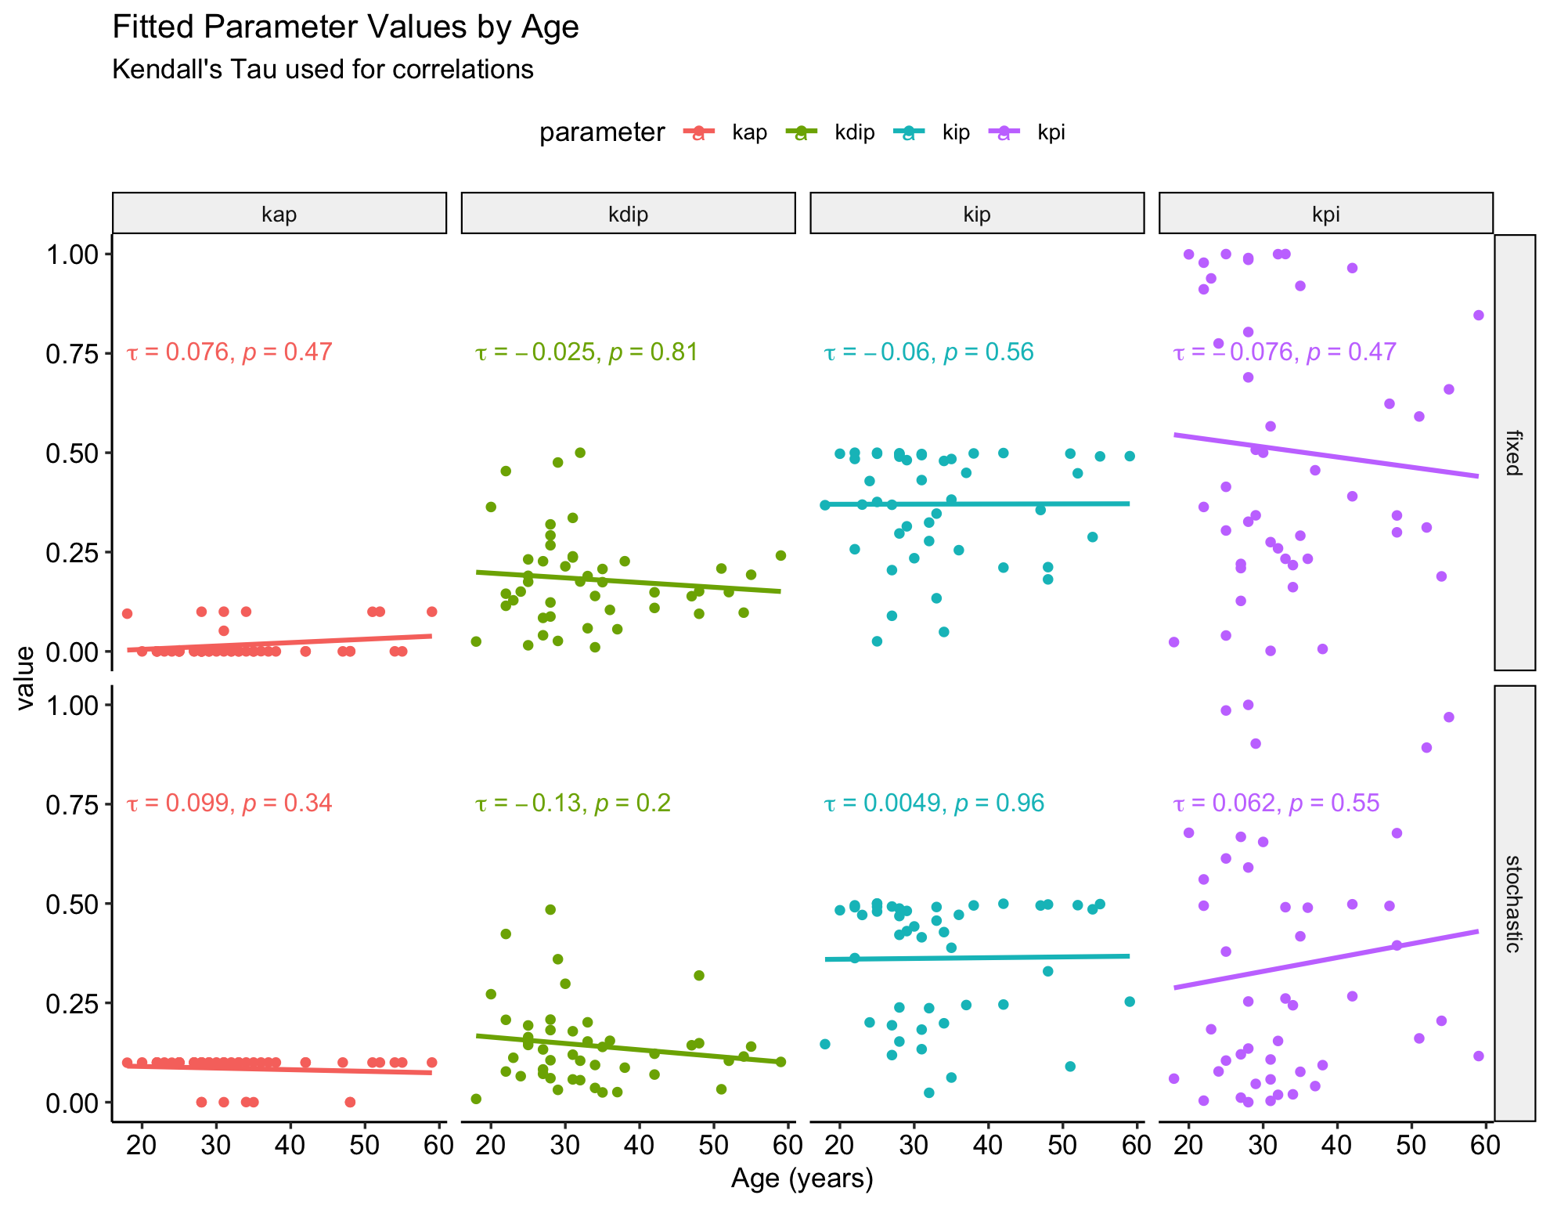

***Figure S2:*** Fitted values from the fixed model (top four panels) and the stochastic model (bottom four panels) for four different parameters: kap, kdip, kip, and kpi. Each dot represents the fitted value for that parameter from a 500 day timeseries of kidney damage data.